Coated Bosch brake discs

When braking from a speed of 100km/h the braking system of a mid-range vehicle must deliver a braking power of over 500 kW.
During a braking application of this kind, temperatures of several hundred degrees
celsius may be reached between the brake pads and brake disc. In addition, braking system components are continually exposed to a range of environmental influences such as water, spray, dust and dirt. Despite all this, today’s drivers not only expect 100% reliability but also maximum braking comfort. Good responsiveness, precise control, no disturbing noise and constantly uniform braking are taken for granted.
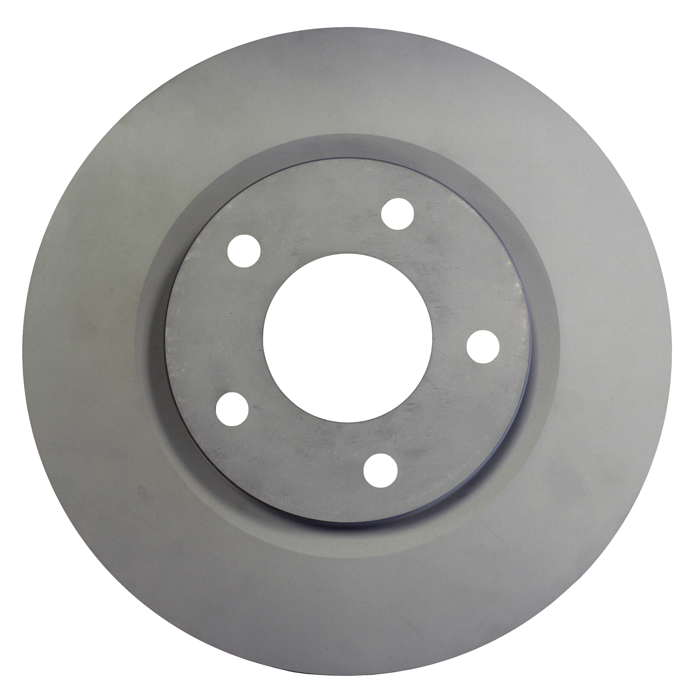
Coating matters
As a leading brake disc manufacturer, Bosch produces over 30 million brake discs per year. With this expertise and knowhow Bosch not only understands what customers’ demand of their brakes, but also works hard to continually evolve its range.

For the Australasian aftermarket Bosch offers a European range of coated brake discs. Bosch’s coatings are made of environmentally friendly materials which require no further treatment before installation. As a result cleaning oily brake discs is a thing of the past.

The coated area of the brake disc remains protected against corrosion even after installation, ensuring an attractive and sporty appearance, particularly in combination with aluminium rims.

When used with the Bosch European brake pads, Bosch brake discs provide outstanding levels of performance and dependability in virtually all braking situations.

Important tips for running in brakes

During brake run-in, please note the following:

- Discs no longer have to be degreased

- First perform 10-20 medium-strong braking operations from a speed of 60Km/h. This is particularly important for fully coated brake discs for only then can a normal coefficient of friction be achieved between the disc and the pad

- Drive with care for the first 60 kilometres of driving after a change of brakes

